**Student’s Project**

**MOROCCO**



**A New Vision for Sustainable Education**

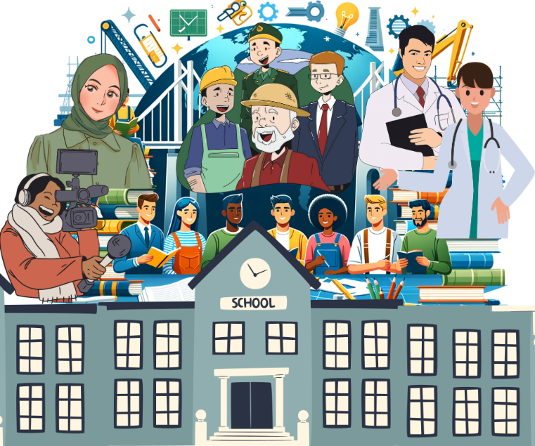

**The researcher : Firdaws Idrissi**

Supervised by : Prof. Mohamed Fettah

School: Moulay Ismail High School

**Outline**

1. **Part One (Theory) ...........................................................**
2. **Introduction.**
   1. An overview of sustainable education.
   2. Benefits of sustainable education.
3. **Strategies for achieving sustainable development.** 
   1. Promotion of global and local policies.
   2. Using new technologies.
   3. Engagement of community and individuals.
4. **Case studies and best practices.**
5. Examples of countries or schools that have made significant progress.
6. Lessons learned from these initiatives.
7. **Part Two (Practice) ........................................................**

* **Creating an online school network through which students who graduated from school can exchange their knowledge and experiences with the students who are attending school.**
* **Organising workshops at school.**

**Abstract**



**This research explores the concept of sustainable education as a cornerstone for achieving sustainable development. It clarifies to what extent it contributes to spreading environmental awareness, social equity, and economic resilience.**

**Clearly, key strategies for achieving sustainable development through education are discussed in this research, including the promotion of both global and local policies that align with sustainability goals. Indeed, the research not only emphasizes the transformative potential of new technologies in delivering sustainable education, facilitating access, and enhancing learning experiences for students but also highlights the importance of providing an active engagement of communities and individuals in the school life.**

**Meantime, the research also incorporates case studies from countries and schools that have made significant progress in integrating sustainable education into their systems. These examples illustrate effective practices and innovative approaches. Therefore, by analyzing these cases, the research identifies adaptable strategies that can be implemented across different contexts to enhance sustainable education.**

**To bridge the gap between theory and practice, the research proposes practical initiatives. The first one is to create an online school network that connects former students with current students, enabling them to exchange knowledge and experiences. Another practical step involves organizing workshops at school to engage students, educators, and communities in hands-on activities that promote sustainable practices and awareness at school.**

**In a nutshell, this research highlights the transformative power of sustainable education in achieving long-term development goals. Because integrating such theoretical framework with practical initiatives provides a comprehensive approach to fostering sustainability in our education systems.**

"The purpose of knowledge is to guide individuals to achieve both personal excellence and contribute to the well-being of society."

Al-Farabi